**WKE Factory View 2014**

User manual



Software Version V1.0

Author Tongsong CAI

Company Wayne kerr Electronics

Email [caicaiking@gmail.com](mailto:caicaiking@gmail.com)

Contents

1. Operating Environment 1

2. Lists of files and installation 2

2.1 Lists of files 2

2.2 Installation 2

3. Log In for Application 6

3.1 Mode option 6

3.2 Connection 6

4. Main Interface 8

5. Tools Bar 8

5.1 Trigger button 9

5.2 Setting test parameter 9

5.3 Setting of display 13

5.4 Calibration 18

5.5 Data view and storage 19

5.6 Storage of graph 20

5.7 Shortcut Button 20

6. Help and Support....................................................................................................19

# 1. Operating Environment

The application can run on 32 bit Windows operating system and 64 bit, while Windows XP and Windows7 have been tested. The resolution of screen upon 1024*768 is recommended to adapted the application.

# 2. Lists of files and installation

## 2.1 Lists of files

Files shown in the figure below cannot be deleted at random, lack of anyone for these files may cause the application’ failure or the lack of function.

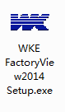

## 2.2 Installation

2.2.1 Double click WKE FactoryView2014 Setup.exe to start the installation.

2.2.2 Initial interface as shown in the figure below.

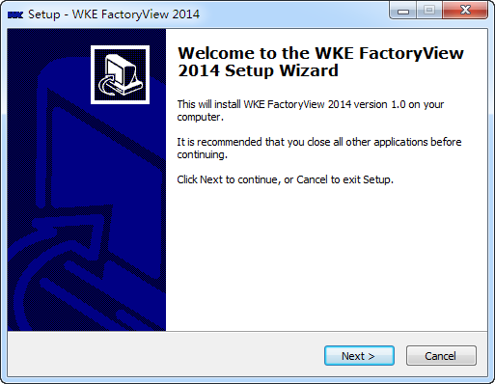

2.2.3 Enter the passwords and click Next .

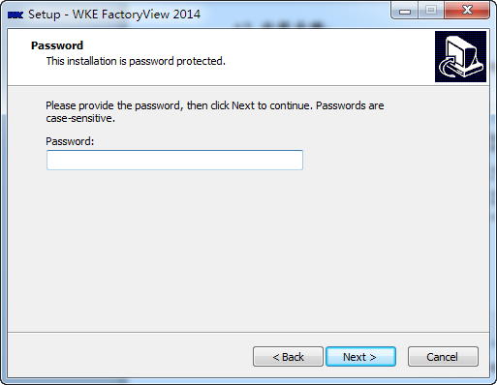

2.2.4 Choose a directory for installation and click Next.

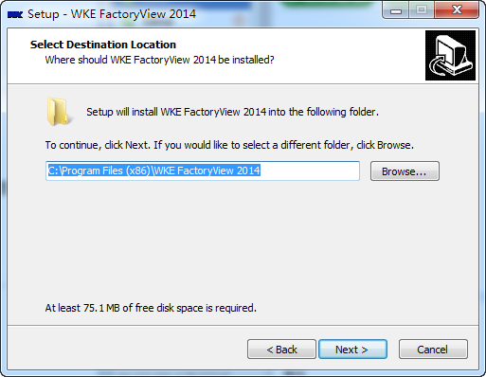

2.2.5 Click Browse to select a folder to place the shortcut of application or just click next if you choose the default.

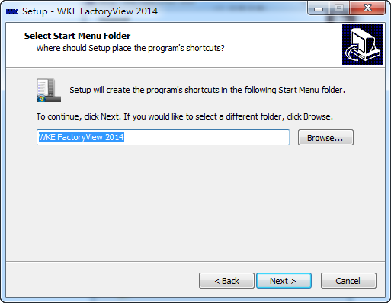

2.2.6 Check the box if you would to create a desktop icon or click Next directly.

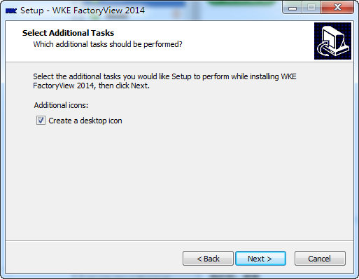

2.2.7 Details of installation will be shown as in figure below, and click Next.

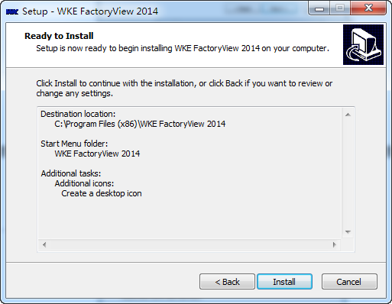

2.2.8 Installation will be complete when the progress bar is complete.

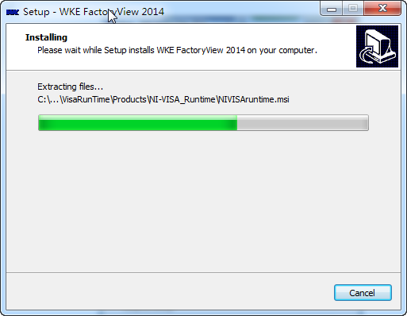

2.2.9 There are two options as shown in figure below.

1) Launch Install visa driver

If this is the first time installation for the application, check the option please, the application will start in failure otherwise.

2) Launch WKE Factory View 2014

Check this option to start the application.

Click the Finish at last.

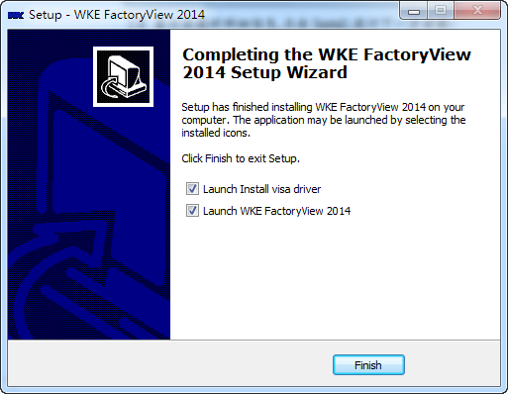

Please restart the computer if the connection is USB.

# 3. Log In for Application

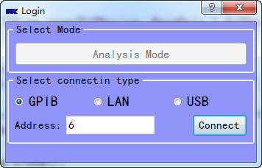

## 3.1 Mode option

Analyze mode is the only option. And click the connect button before select the test mode.

## 3.2 Connection

There are three options: GPIB, LAN, USB.

3.2.1 LAN

Connect the PC and WK instruments via a network cable.

Set IP address by the steps below.

1) Refer the related user manual to set the IP address of instruments.

2) Set the IP address for PC: network neighborhood→查看网络连接->本地连接。双击Internet协议（TCP/IP）。Set the IP address as shown in figure below.

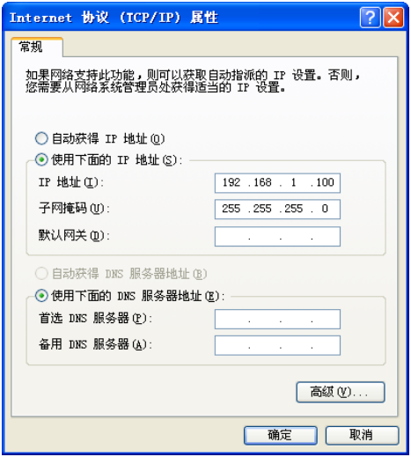

3) And check the connection between PC and instruments by ping order of windows as shown in figure below.

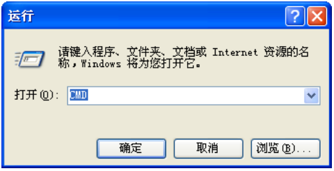

4) Connection will work if the figure is presented as shown below.

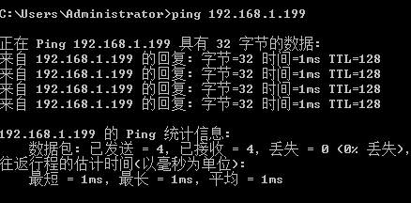

5）If the instrument belongs to WK4300 series, set IP address as shown below.



6)If the instrument belongs to WK6500 series, set IP address as shown below.



3.2.2 GPIB

Address in address bar should keep pace with that of instrument.

3.2.3 USB

Connect the PC and instruments via a data wire.

# 4. Main Interface

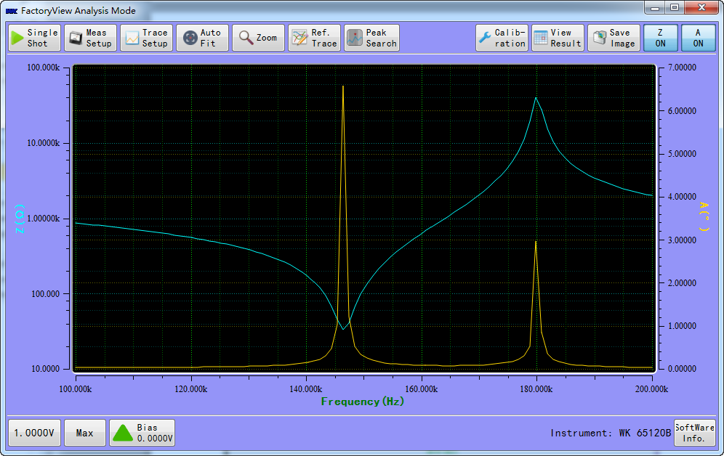

（Screen shot for analyze mode, while the sample is [piezoelectric](javascript:void(0);) [ceramic](javascript:void(0);) [piece](javascript:void(0);)）

# 5. Tools Bar



## 5.1 Trigger button

: Click the button to conduct a scanning test.



## 5.2 Setting test parameter

:

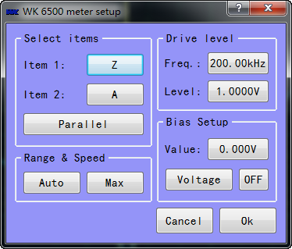

Interface below will be presented after the Term1 or Term2 is clicked. Select

the parameter need to be tested.

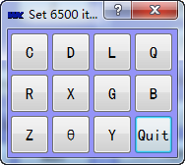

Click the freq to enter the values as shown in figure below. Settings of drive level and DC bias are the same with freq.

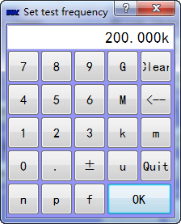

: setting of scanning



Click the button to set the range of frequency and DC bias, scanning time, scanning points, titles of tests and display range of terms. All of these operations are shown in figure below.

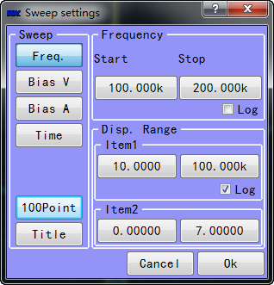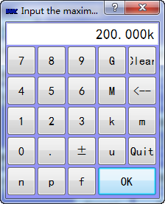

:Setting scanning points is presented as in figure below.

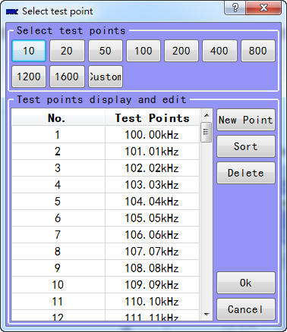

User-defined : allowing users to define the quantity of scanning points.

Addition: allowing users to add the special points into scanning range

Sorting: allowing users to sort the points from small to large

Delete: allowing users to delete the points

Note: please click the button of scanning points before scanning to insure range of scanning accords with settings.

## 5.3 Setting of display

: Click this button to allow the test curve to fit the screen. Test curve not fitting the screen is shown in figure 5-3-1, while test curve fitting the screen is shown in figure 5-3-2.

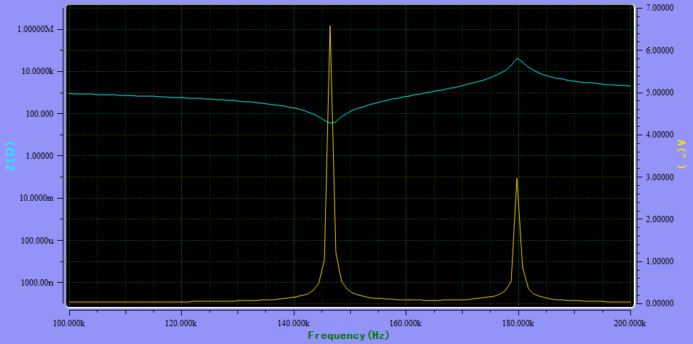

figure 5-3-1

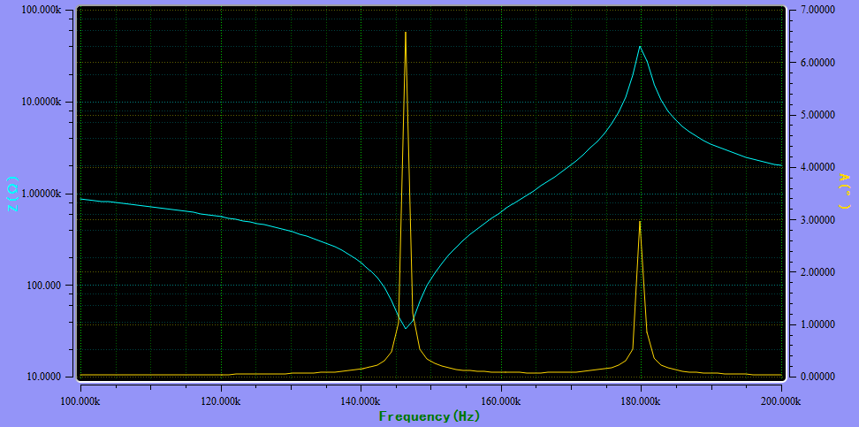

Figure 5-3-2

: Click this button to define the range where scanning need to be conducted in detail. Application will conduct scanning in area defined automatically Primary test curve is shown in figure 5-3-3, while the test curve enlarged is shown in figure 5-3-4.

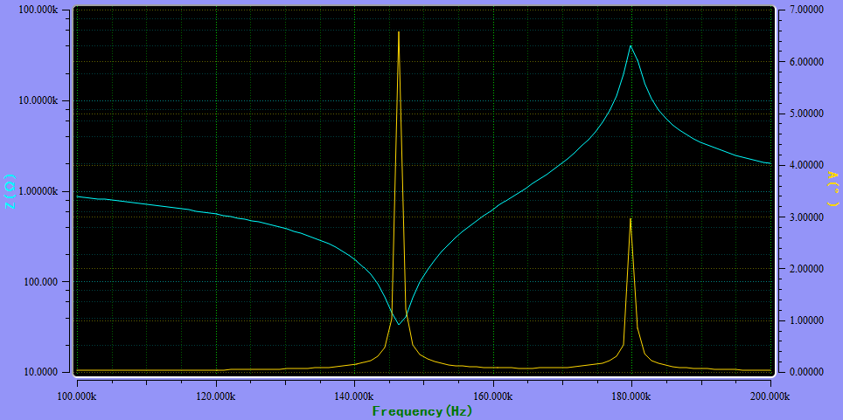

5-3-3

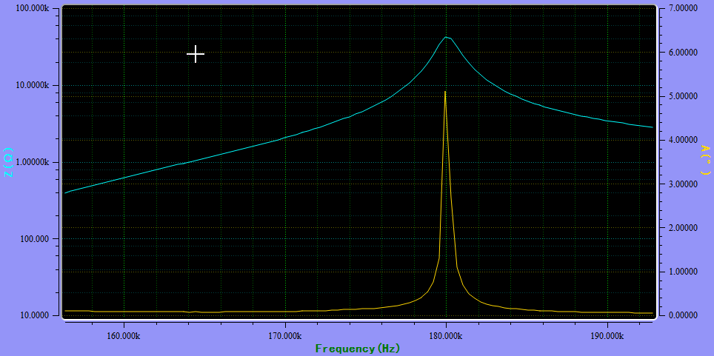

5-3-4

: Click this button to compare test curves and interface will be presented as below. In this interface, users can mark current curve with a number.

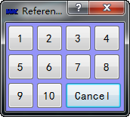

Interface will be presented as below after operations above. Insure the ON/OFF button remains ON. Select the color of curve and enter the title of it. Click OK to finish it.

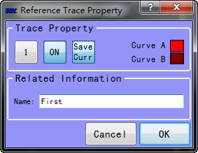

Click the trigger button conduct comparison test. If the ON/OFF button remains OFF, curves saved cannot be shown in screen. Comparison is shown in figure below.

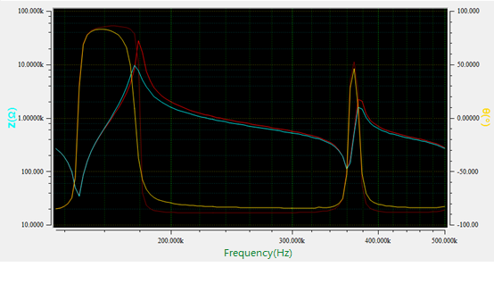

The Peak Search facility may be used to identify peaks, or dips in a measurement trace. Selecting the Peak Search command button will produce a new set of command buttons at the top of the display.

: Finds the maximum or minimum value on the active trace. In figures below, peaks are found, which is marked by cursors.

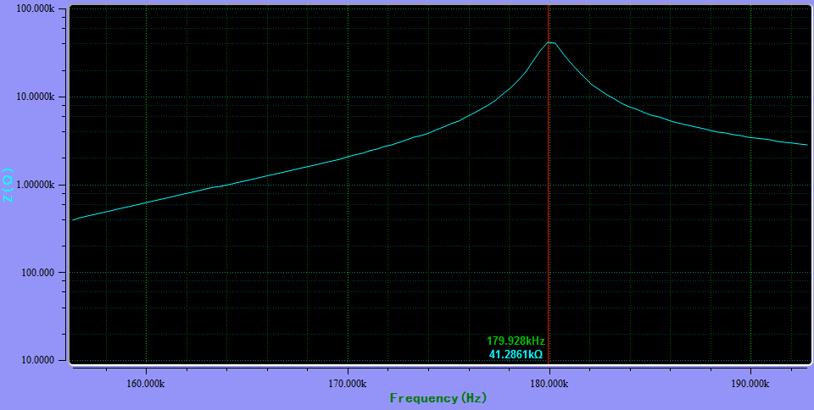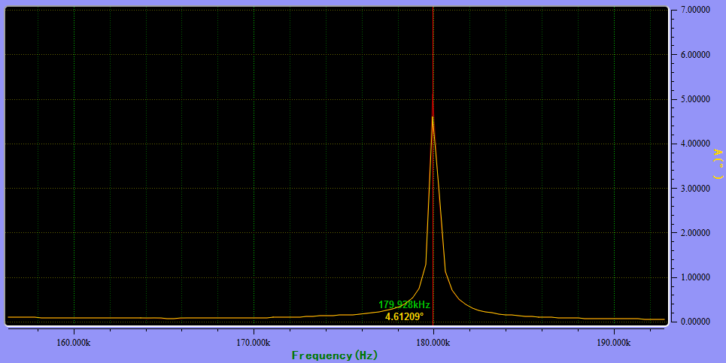

: Each time, Next Left finds the next peak to the left of the marker’s current position, and Next Right finds the next peak to the right of the marker’s current position.



:Click this button to switch on/off test curves of term1, e.g., curve of Z is closed in figure below.

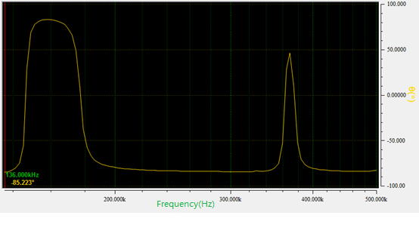

: Click this button to switch on/off test curves for term1, e.g., curve for θ is closed in figure below.

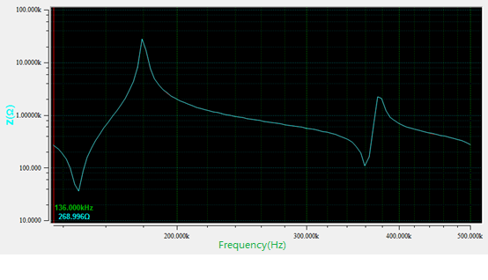

## 5.4 Calibration

: Interface as below will be presented, including open calibrate, short calibrate and High-frequency calibrate.

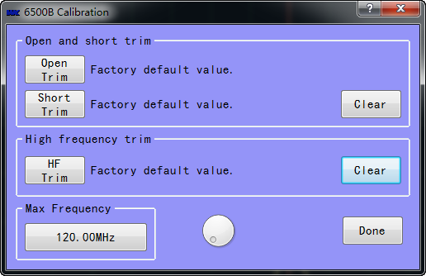

## 5.5 Data view and storage

：click this button to browse the test data as below. Users can click Save to save the data and click number of group to change curves.

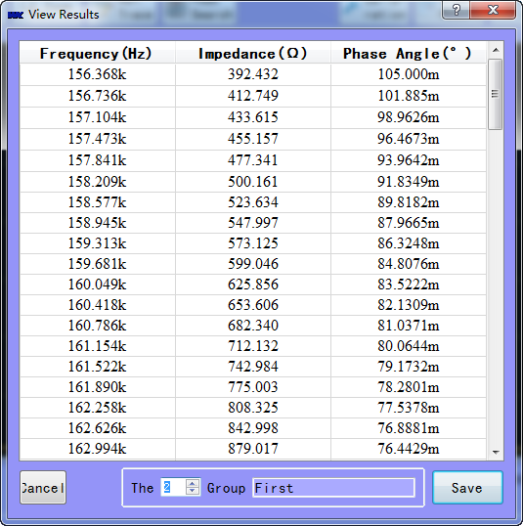

Application allow users to save data of several terms for a scanning test as below.

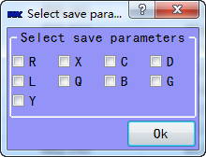

## 5.6 Storage of graph

: Save the test curves, while default format is png.



## 5.7 Shortcut Button

: Click this button to set the frequency of test.



: Click this button to select the speed of test.



: Click this button to set the drive level of test.



: This module displays the status of DC Bias. It’s OFF when the color is green.



: CAUTION! This module displays the status of DC Bias. It’s ON when the color is red. Please turn off the DC Bias when test is completed.



6. Help and Support

【WKE Factory View 2014】

Author: Obama

Email: [caicaiking@gmail.com](mailto:caicaiking@gmail.com)

At last,thanks for your choice of this software program, and we will appreciate your feedback and proposes.